### Water and conflict on the Jordan River[[1]](#footnote-1)

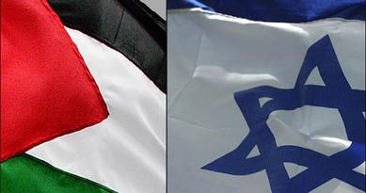

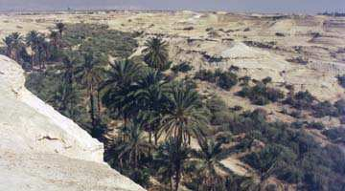**Introduction**

Most people will not need much introduction to this problem, the participants are doing their best to keep it perpetually in the news. In this project you will encounter a system consisting of several subsystems, physical, social and economic. Both components and structures of components will be important in linking to sustainability. You have the components in some aspects visible, the National States, the ethnic units, the economic divide inside the ethnic groups, politically and economically, but also systems for water or food production. The purpose is to make a model for a system with no apparent obvious solution, in order to try to better understand the problem system, investigate possible solutions, assess if any of them are to last, can be sustainable. This task was composed in 1998, and the conflict has evolved much since then, much to the detriment of the Palestinians. We are now in the years 2021 in this edition of this book, but the problem is still there, the state of the system is different, but the driving forces are much the same as earlier.

**The story**

This conflict problem is a very real one, and one that has pestered this region for at least 3,000 years, maybe more. The last update is available in today’s newspaper, recently, they have invested effort in escalated violence and infrastructural damage. During history, the people in the region has had a large number of violent conflicts over land, water and dominance. Very many people have had the opportunity to have an opinion on the issue. Many interest groups have international political ties and religious bindings to issues and dependencies. Many population groups have quite legitimate claims to the same area at the same time, making exclusiveness of possession a quite foolish illusion. Very many have old scores to settle, the whole area can be said to be poisoned by it's history and memories. This is making all political solutions very difficult and it is impossible to find any solution that would please all in the short term. In the long run, development of the region's education level and reshaping of attitudes will be an important for a sustainable solution based on sound knowledge, tolerance and a good standard of living shared by a majority of the population. May be parts of the history is doing better service as forgotten than as remembered. The political climate in the region is boiling. There is a tendency to polarize questions within both the Israeli and Palestinian community, often exploiting religious feelings. Political agitation can hardly be distinguished from religious, and we need to analyse effect and cause. Possibly it will help to map how religious and political activities affect the state of mind and the decision processes.

The countries Jordan, Israel and parts of Lebanon and Syria all share the freshwater of the River Jordan, to a lesser degree this is also affected by Syria and Saudi Arabia in their use of groundwater. The region is fairly densely populated and both land and water is hotly contested because it comes in very limited supply.

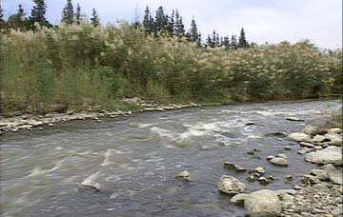*The river Jordan is not a large river any more, because of the intensive use of its water. This river would carry an annual average of 44 m3/s into the Dead Sea. Most of the tributary to the Sea of Galilee is extracted, and the outflow of the Sea of Galilee is from very small to often nothing.*

The different parties optimize for their own members rather single-mindedly. A proportionally too large success in gaining a large share of the land, power. water or any other essential resource for one group, may precipitate quick disaster for all the other groups. If one group fall below a certain level of individual water supply, then the only option available is to gain access to the resource by force, a strike, a riot, or in the worst case, a war will break out. Water is needed directly as a food in its own right, but also to keep minimally clean to maintain good health. Substantially more is required to irrigate land and produce food. If the water supply fall below the daily requirement in a region, the immediate answer is often a violent uprising. If it falls below requirement in a whole country, either a war will ensue or there will be a significant increase in mortality. War becomes profitable when the mortality cost from famine exceeds that of a war. In the long term, lack of food will lead to the same situation.

**Simplified pictures of the political principles at work**

The problem can be complicated by the following; Inside Israel, there are two major groups in the Jordan Valley which compete for water; (1) The Israeli population that hold most of the military power and the hold possession of most of the land (2) the Palestinians which hold less power and has a weak grip on the land they hold. Water resources for consumption and irrigation is unequally divided among these groups. Water overuse threatens the stock of groundwater in the whole region. The social structure in the Palestinian group is also shifting. Due to economic restrictions, the middle class in the Palestinian population is decreasing in numbers, as unemployment and education disruptions continue. Inside, both the Israeli and Palestinian populations are divided between those entrenched in ideology and religion, those that try to solve issues through dialogue and peaceful means.

Both states are struggling with their democracies, as several fractions lack respect for personal integrity and could be said to set ideology and religion before reason and tolerance. Religious schools and fundamentalist groups represent a special problem with all parts, as many of them seem to foster attitudes that do not increase tolerance and respect for peoples of different opinion or other faith or ethnicity.

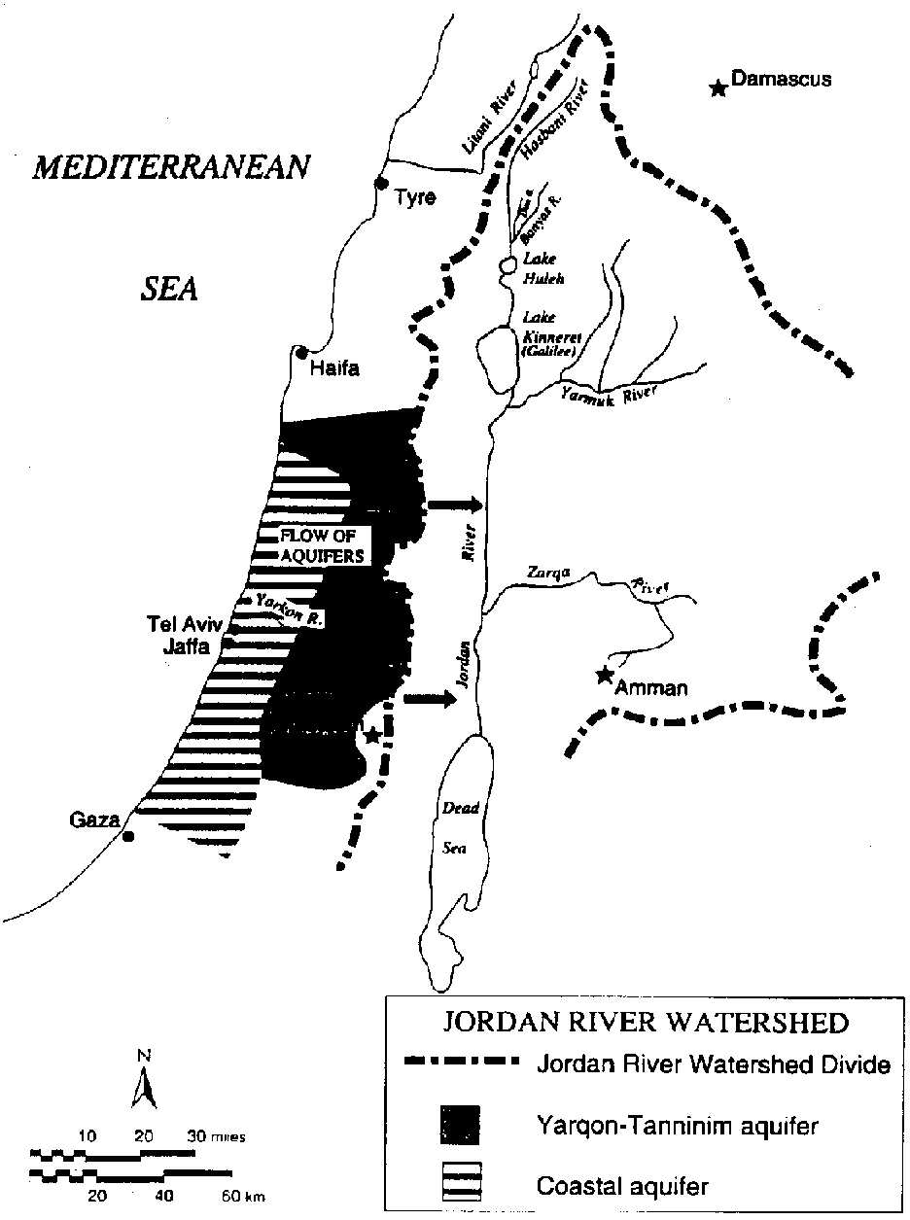 In many cases the religion has become instruments of raw power and greed, betraying the core values of the religions they claim to defend. Since the physical and demic problems are large, and the fact that sustainable solutions can only be created by cooperation, the intolerances in all its aspects are one of the large problems of the region.

A continuing problem remaining is the use of force to seize land illegally and the lack of proper justice institutions that extend across ethnic divides to deal with injustices. Despite the failure of such policies of the past, they continue. At the moment one side has the upper hand, but there is no doubt that all partners would do the same if given the change. This is a matter of attitudes and moral values that needs to be changed in a fundamental way.

Jordan is a traditional monarchy and the King holds the real power. The power over resources and land is in the hands of numerically few landholding families. There is a large number of commoners with very modest or no land holdings. There are large aquifers located on both sides of the Jordan River, all which are tapped and controlled by the local landowners, secondly by the authorities. The large landowners control a larger portion of the groundwater resource compared to their fraction of the country's population.

The partners in the region are only partial democracies, and not evolving towards stable democracies and a future equalization of the standard of living between the countries at present. The rate of progress will be much connected to education possibilities, resource sharing, relief from social stress, as well as evolution of a secularized society focused on standard of living and personal free choice.

Finally, abandonment of the concept of revenge is essential for a civilized society. States that still allow personal, clan-based, politically based or ethnic revenge cannot be counted among civilized nations. Revenge has the nasty property that the hurt from an insult is always larger than the gratification of taking revenge, thus it normally escalates to exhaustion. Revenge often hits, people peripheral to the original dispute, steadily increasing the recruitment for more revenge. We need not mention any names, it is easy enough to read an international newspaper to see that it still goes on on many levels, all the way up to nation states. When the remote and barbaric kingdom of Norway in 872 AD outlawed any type of revenge, declaring that the revenge after that time always belonged to the King of Norway, to be exclusively executed through courts of justice associated with the National parliament, then in that very moment the wild country became civilized. Some states have not yet come that far.

Sectarianism is a nasty political practice, it is indeed political, even if it is sometimes disguised in religious terms. The purpose is to amplify and strengthen certain political motives and make them transfer to more people. Almost always, there is some type of power scheme behind it, containing the real agenda. On both sides in the Israel-Palestina conflict, there are group that out of self-interest and craving for power indulge in such practices, making conditions for discourse and compromise very difficult. Strong elements of religious rhetoric is associated to these practices, making them further more difficult to question, reject or ignore. A further complication in the system is represented by the displaced population groups in refugee camps, as well as the split of the Palestinian population and territories into two warring factions. In 2007, Gaza area went its own way under Hamas party rule, becoming politically separated from the West Bank ruled by the Fatah party. Blockade by Israel has strangled Palestinian exports and imports to a minimum, severely damaging all Palestinian economy, causing tension and hatred. In societies under great stress and small perspectives of change to the better, conditions are favourable for religious and political extremism. In political discussion clubs and secluded religious circles this festers further and promotes attitudes of revenge and violent answers to simplified questions.

**Basic river hydrology**

The watershed of River Jordan is 18,300 km2. There are several tributaries, from Libanon comes the Hasbani river with an annual average flow rate of 4 m3/s in Israel, the Dan river originates, the average flow is 8 m3/s the Banias river come from the Golan heights, flow is 4 m3/s. These converge and flow to the Sea of Galilee. Approximately 10 km below the Sea of Galilee, (Lake Kinneren, Genesaret Lake, Lake of Tiberias) River Jordan is joined by the Yarmuk river from the east, its average annual flow rate without water extraction should be 15.8 m3/s The Yarmuk River was Jordan’s most important source of water, recently a significant part of it was dammed and diverted to Syria. At present Jordan receives an annual average of 4-6 m3/s from the Yarmuk. Halfway between the Sea of Galilee and the Dead Sea, the Zarqa river joins River Jordan. It comes from the district north of the city of Amman in Jordan. The Zarqa River is much smaller than the Yarmuk and during the dry season it almost dries up completely.

|  |  |  |
| --- | --- | --- |
| Tab. 2. *Short overview of the available water resources in the Jordan Valley in km3/yr. At present, Jordan would need to intensify agriculture for better self-sufficiency, and would for that sake need to use more water. At present the Jordanian population grows with approximately 4.5% annually.* | | |
| Country | Israel | Jordan |
| Internal renewable surface and groundwater | 2.2 | 1.7 |
| River flow from other country | 0.5 | 0.5 |
| Total renewable water | 2.7 | 2.1 |
| Annual use 2000 | 1.85 | 0.45 |
| Population in 1995, million | 5.6 | 5.4 |
| Estimated population in 2025,million | 7.8 | 12.0 |

At the end, at the Dead Sea, the annual average flow rate is 1.4 km3/s, or equivalent to 44.4 m3/s, provided nobody takes water from the river upstream. Little of this remains in the river when it reaches the Dead Sea. During the last decades the level in the Dead Sea has dropped more than 15 meter, the level in the Sea of Galilee has also dropped several meter. Because of the large evaporation in the warm, dry climate, any significant use of water from the Jordan must lead to level drops in the Dead Sea. Lowered lake level also cause a lowering of the local groundwater table. The climate is Mediterranean semi-arid to Middle Eastern desert. The major part of the precipitation falls in the four winter months, but total amounts vary very much between years. The highest annual average in the catchment is 700 mm/yr in the north on the Golan and Hermon heights, down to approximately 100 mm/yr in the desert of North eastern Jordan. Annual potential evaporation is between 500 and 1000 mm/yr the effective runoff to rivers and aquifers is 75 mm/yr for the whole area.

**Groundwater hydrology**

The aquifers are important sources of water in the area. The Yarkon-Taninim aquifer recharge approximately 0.335 km3/yr in the western part, the northern part go into northern Israel with 0.14 km km3/yr and the eastern with 0.125 km3/yr toward the Jordan valley (4 m3/s ). 50% of the northern and eastern yield brackish water with more than 40 mg/l of salts. After occupation of the West Bank, Israel controls a major part of the water available from aquifers. The size and yield of the Syrian, Lebanese and Jordanian aquifers inside the watershed is at present unknown to us, but we believe them to be smaller than the aquifers on the West Bank. Groundwater aquifers in the region are sustainable water sources when extraction is less than the effective percolation in the catchment area. Large scale extraction of groundwater which lower the levels in the reservoirs will also in the long run reduce the water flow of the small seasonal rivers (wadi) during the rain seasons. The additional sources of water are limited. One is freshwater on returning oil ships. Recirculation is also an option, clean water for drinking, reuse of wastewater and grey water for irrigation.

**Politics**

The politics of the region is very polarized along hard frons in the region, both between the ethnic groups and within them. Important for the analysis is not what their ideologies and dogmas are, but the real-politik the are actually enacting. How the different sides are using the methods of political power, physical force and as well deliberations, but also involving abuse of power and different degrees of corruption.

On the Israeli side there are confrontational groups and conciliatory groups as well as fundamentalistic religious groups with none or little will to do any compromise. Israel is a partial democracy, and has a certain amount of feedback on the political leadership. It has a significant problem with abuse of power by strong individuals and oligarchism behind the scenes.

On the Palestinian side, the group is also divided along similar principles, and in reality there are two Palestinian groups with very different policies and approaches, as well as external alliances. For both the Palestinian groups, widespread corruption is a major issue, and the corruption has largely destroyed Palestinian democracy, economy and political efficiency. Another damaging factor is sinking education levels as a result of an education system that has been targeted and severely damaged by different opponents (Opposing Palestinian and Israel military forces) as well as religious fanaticism.

**Your task**

You are one of junior conflicts analysers in a 4 person team at the United Nations Economic Commission for the Middle East (UN-ECME) associated with the UNEDP, and your task is to present a systems analysis of the regions water supply problem and its connection to the mechanisms of the Jordan Valley conflict, especially being interested in the feedbacks in the system. The UN-ECME wants to prevent potentials for future war between the nations and war between social groups, and decrease the risk for armed conflicts, with all the environmental devastation and disasters this generally implies for the civil populations. You work within the United Nations ideal, always seeking to promote protection of personal health, human rights and integrity, always protecting and promoting democratic behaviour, striving towards sustainability, staying impartial but very fair.

Your task is to try to take part in a concerted team effort to make a scientific and as impartial as possible analysis of the system dynamic properties of the conflict. Thus you should suppress your emotional or political preferences, and separate it from your professional understanding of the mechanisms involved in the problem. Especially becomes the analysis of the mechanics of the conflict system and how it is linked to decisions and promotion of different kinds of attitudes.

The team makes the analysis of necessary components, simplifications, structural analysis and collect the necessary information from literature and from libraries. Present your teams analysis of the problem, explaining its dynamics. Suggest possible system changes based on your model for the problem (Technical system, industrial focus and structure, political system, supply systems, external limiting systems).

Important for solving this problem is to figure out how the social systems interact. Equally important is to figure out how the physical system is coupled to the social and how it may increase social stresses that in turn may lead to conflicts and even societal collapse. A challenge is that there are several sub-societies that interact as bodies, but several physical systems are common.

**The problem**

The problem of water shortage is expected to increase in this region for the next 30 years. Once the dynamics of the system in terms of water use and decision mechanisms can be understood, then only do we understand which changes that can be proposed and brought to change the situation into a permanently more stable and fair situation. If the present trend continues, then the region may suffer a large water deficit in the next decades, increasing the risk for violent conflicts significantly.

1. When will water shortage occur ? How severe will it be ? What is the minimum water requirement per person ? One source gave 100 m3 per person and year as the minimum for survival, but is that a realistic estimate ?
2. How large could the different population groups get ? When will population numbers become a problem ?
3. What does the Johnston and Wolf plans and other water right treaties in the region imply ? What happened after these plans?
4. Is a war likely if the problems are not addressed in time ? Can the present system be decoupled and reorganized to prevent violent crisis ?
5. Can the water crisis be prevented by water imports or recycling ? Would a 30\% recirculating of all wastewater improve the situation ? Would it help to import water, using oil tankers on return to the Persian Gulf ? Annually, returning oil tankers destined for the Persian Gulf could theoretically deliver water at Gaza or in the Gulf of Akaba (Suez-Max ships), 50 million ton/yr water of irrigation quality) and an additional 400 million ton/yr (Afra-Max ships) could be delivered in the Persian Gulf, Jordan could theoretically get 25% of this.
6. So far we focus on water as a physical resource. Are there others we should, could or must considerer ?
7. Use some time to think about social resources (cultural heritage, social trust, trust generating mechanisms) but also social pollution (distrust, prejudice, intolerance, hatred). How to handle them ? How to make them into generalized and countable entities ? (The humans do that already, mostly without knowing, but can you see it, and how ?)
8. Are the political mechanisms and systems in the region adequate ? Consider that the possibility would be available that you could change some of the political mechanisms of the different problem partners or their policies for use and distribution of land and water resources.

### A paradise lost (?) -- Galapagos Islands[[2]](#footnote-2)

 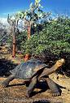 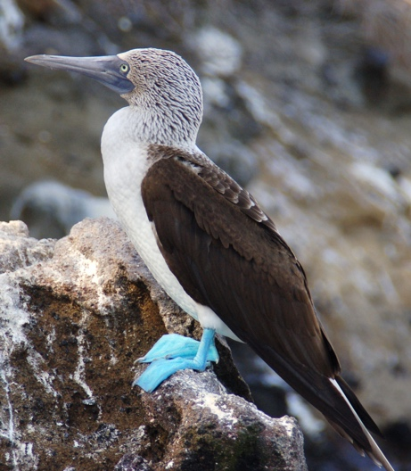

Balancing environmental protection versus jobs and money

**Introduction**

Few would argue that the Galapagos Islands represent one of the greatest biological treasures of the world. Widely recognized as the birthplace of evolutionary biology, these "enchanted islands" have captured the imagination of scientists and nature lovers since Charles Darwin first visited them in 1835[[3]](#footnote-3);

*Considering the small size of these islands, we feel the more astonished at the number of their aboriginal beings, and at their confined range. Seeing every height crowned with its crater, and the boundaries of most of the lava-streams still distinct, we are led to believe that within a period, geologically recent, the unbroken ocean was here spread out. Hence, both in space and time, we seem to be brought somewhat near to that great fact that mystery of mysteries - the first appearance of new beings on earth.*

Millions of years of geographic isolation, a unique combination of oceanographic characteristics (deep-near shore waters, cold upwelling ocean currents, strong currents, and dense plankton populations), and a wide variety of habitats have created the extraordinary biological diversity found within the Archipelago. The famous terrestrial fauna, including Galapagos tortoises, marine iguanas, Flightless Cormorants, and Red- and Blue-footed Boobies, show little fear of humans and have made the Galapagos a Mecca for nature-loving tourists. Although less well known, the marine fauna is also highly diverse because of the range of underwater habitats and ocean currents the draw in both temperate and tropical species. Nearly 17% of the fish species are endemic, and there are 27 species of sharks, including schooling hammerheads and the giant whale shark[[4]](#footnote-4). Because of the foresight of Ecuador's leaders, assisted by the global conservation community, the Galapagos Islands have long been an international model for the protection of biodiversity. But recent pressures to exploit the marine resources of the Archipelago call into doubt whether any protected area can withstand the economic pressures of development and human population growth.

**History of exploitation and protection**

Although the Galapagos lie 950 kilometers off the South American mainland, exploitation of its marine resources has a long history. Permanent human settlement of the Galapagos began in the 1830s and was accompanied by the introduction of exotics like goats, pigs, dogs, and black rats. In 1934 the government of Ecuador set aside some Galapagos Islands as a wildlife sanctuary. In 1959 the islands were declared a National Park. Until recently the relative inhospitality of these remote islands (extremely low rainfall and limited freshwater) has kept human population growth in check. In the 1980s population grew primarily in response to growth in tourism and tourism-related industries. In the 1990s immigration has been fuelled by the opportunity to make quick money in the lucrative export fisheries recently sanctioned by Ecuador. Immigration from the mainland is responsible for about three-fourths of the 8.5% annual growth and is straining the already inadequate health care, education, and infrastructure of the four communities of the Islands. The population is now estimated at almost 15,000 residents. As on most oceanic islands, loss of endemic species through the introduction exotics has been the single greatest threat to the unique biodiversity of the Galapagos. From the 1960s to the 1980s efforts to eradicate some of the more destructive introduced species, such as goats and pigs on a few of the islands and black rats in some seabird colonies, were successful. Galapagos retains over 95% of its original biodiversity. But as human population grows, tourism expands, and the presence of people (mainly fishers) on the more remote islands increases, so too will the rate of introduction and loss of endemics inevitably increase.

The Galapagos have been a focus of global conservation efforts for decades. In 1959 the designation of the Galapagos National Park by Ecuador provided protection for the terrestrial environment. Nearly 97% of the land area is now included in the national park. The islands were also declared a World heritage site in 1971 and a UNESCO Man in Biosphere Reserve in 1984. Ecuador deserves international recognition for spearheading these conserv­ation measures. Protection for the marine environment did not come until 1986, when the Galapagos Marine Resources Reserve (GMRR) was established. Covering 70,000 km2, including the interior sea of the Archipelago and out to 24 km, the GMRR is second only to Australia's Great Barrier Reef Marine Park in size. In addition since 1990 all inland waters have been declared an Inter­national Whale Sanctuary. Other legislation prohibits the capture and trade of any sea turtle species within Ecuadorian waters.

Through the diligent work of the Charles Darwin Foundation, in co-operation with scientific and technical experts from around the world, a management plan for the Marine Reserve was developed and signed into law in August 1992. The plan provides a biologically defensible zoning scheme that allows for local, traditional, and artisan commercial fishing in the Reserve but severely curtails industrial-scale fishing[[5]](#footnote-5) (Jennings et al. 1994). Yet there has been continual pressure by national and foreign fishing interests to legalize major commercial fisheries for export of sharks, sea cucumbers, lobsters, and sea urchins. As this species-by-species' exploitation continues, the integrated management plan has not yet been implemented.

**The threat of commercial export fisheries**

The Charles Darwin Foundation identifies large-scale commercial fishing as the single greatest threat to the marine environment of Galapagos. Despite Reserve designation, illegal, industrial-scale fishing in Galapagos has been rampant over the past 5 years. Clandestine shark fisheries were discovered in 1988 and 1991: Tens of thousands of shark have been killed for the Asian shark fin soup market, at times using the Galapagos sea lion as bait[[6]](#footnote-6). In 1992 an extensive illicit fishery also developed to export protected sea cucumbers for the Asian food market. Lobsters have been subject to a 7-year fishing moratorium to prevent their extermination. Up to 80 major fishing vessels from Japan, Taiwan, and Korea, licensed to fish for tuna, are illegally long lining for sharks and trading in other marine species within the Reserve. Motivated by foreign fishing interests and by government indecisiveness, Ecuadorian fishers pressured the government to lift the previous fishing bans in the Marine Reserve. On 23 June 1994, the government yielded to this pressure and reversed long-standing policies, signalling its intent to open the Reserve to large-scale commercial fishing for sharks, sea cucumbers, and lobsters. The tourist industry and scientific communities voiced immediate consern6

Sea cucumbers are a highly prized delicacy in Asian cooking and a purported aphrodisiac. In 1993 the Darwin Foundation requested that IUCN conduct an assessment of sea cucumber status in Galapagos. The study concluded that sea cucumbers had already been extirpated in a number of locations and that the ban on sea cucumber fishing in the Reserve should be maintained. Despite the advice, Ecuador opened a three-month fishery on 15 October 1994. Although a quota of 550,000 was established, no effective controls or enforcement were applied to the fishery. By the time the government responded to public pressure and closed the fishery on 15 December - one month early - about 6-10 million sea cucumbers had been collected, 12 to 18 times their own quota. The "pepineros" (sea cucumber fishers) reacted violently to the closure, seizing control of the Charles Darwin Research Station and Galapagos National Park headquarters on 3 January 1995. Demanding that the fishery be reopened, they held station and park workers hostage for three days, threatened to kill the giant tortoises, and demanded the resignation of the directors of the research station and the national park.

To the credit of Ecuador the government refused to accede to the hostile demands of the pepineros and announced that any decision to reopen the sea cucumber fishery must await the findings of a two-month-long government evaluation of the fishery[[7]](#footnote-7). There is concern that the study may be little more than an effort by Ecuador to justify reopening the fishery and to circumvent criticism of the exploitation. One of the most troubling consequences of the get-rich-quick exploitation in the Galapagos Marine Reserve is that it is encouraging immigration of fishers from the already overexploited fisheries off the mainland. Fishers can make $2.50 per pound for sea cucumbers, which is about 20 times more than they make fishing for other species[[8]](#footnote-8). Prior to the illegal expansion of the sea cucumber fishery about four years ago, only 120 fishers were active in the insular fishery. Today, although 411 fishers hold valid sea cucumber permits, it is believed that more than 1300 people are operating in the fishery. Pepineros have made camps on several of the more remote and pristine islands, including Fernandina and Isabela, to process the sea cucumbers for export. Mangrove trees are being cut for their cooking fires, destroying the only remaining habitat for the most endangered of Darwin's finches, the Mangrove finch. Although the sea cucumber fishery is officially closed, blatant illegal fishing continues. Also illegal shark fishing continues. A grass root environmental action group, made up of Galapagos residents, business people, and ex-tour guides, has recently formed to monitor fishing activity and to pressure authorities to enforce standing regulations. International tourism to the Galapagos accounts for 30-45% of Ecuador's tourist earnings (Honey 1994) and more than pays for the operations of the Galapagos National Park (ecotourism in the islands generates US $ 60 million yearly). The majority of the Galapagos residents are supported by the tourism sector. Annual visitation has grown from 4500 in 1970 to 50,000 in 1994[[9]](#footnote-9) and causing its own problems. There is also a current pressure to admit larger tourism vessels (> 400 passengers) and to develop new visitors' sites. Some years ago, the Galapagos Islands were also struck by a severe accident. The tanker Jessica, owned by Acotramar, ran aground in the bay of Puerto Baquerizo Moreno on the island of San Cristóbal.

**Your mission**

You are going to help out both the Ecuadorian government and their Department of Natural Resource Planning and their Department of Tourism. Large influential groups such as the mainland fishing and tourism industries have now agreed that smaller local interests should join in discussions concerning the islands' problems. Ecuador's Congress then legislated official status for the previously unrecognized local groups, granting them power to set their own goals for sustainable resource use. How can The Galapagos Islands be saved for future generations at the same time as how it can be gently used in a sustainable way for tourism and area development? And third – How can the Galapagos Islands and the surrounding area be used? Is it possible to develop sustainable tourism? And if so, at what level ? Can you suggest a development plan for the next 10 years ?

What are the limiting factors, over short time and over long time? What is the population size that the islands can support, over short time, and over long time perspective? Which are the limiting resources? The recommended method of formulating system dynamics models is as follows:

1. Establish a dynamic problem definition and identify the major parameters:
2. Formulate a hypothesis about the feedback mechanisms causing the observed problematic behaviour. Draw up a casual loop diagram, clarifying the relationships between the parameters.
3. Start easy by outlining the most important factor(s), for example… ...
4. Establish the flows between the parameters.
   1. Which are the inflows?
   2. Which are the outflows (maybe it is enough with one inflow and one outflow to start with)?
5. What units do the parameters have? What units do the flows have?
6. Add more parameters, one at a time.
7. Assume that the populations only consist of one type, (at least to start with).
8. Create a STELLA model. Start simple, as usual. Before adding more parameters, run the model and get it to be in balance. Before you run the model, make an assumption of what will happen.
9. When you are satisfied with the model development - investigate different scenarios.
10. Prepare a report to UNDP of your model and your conclusions. Include immediate measures, a development plan for the next 10 years, from the Equadorian viewpoint, and a long-term scenario analysis.

### Oilwellfare[[10]](#footnote-10)

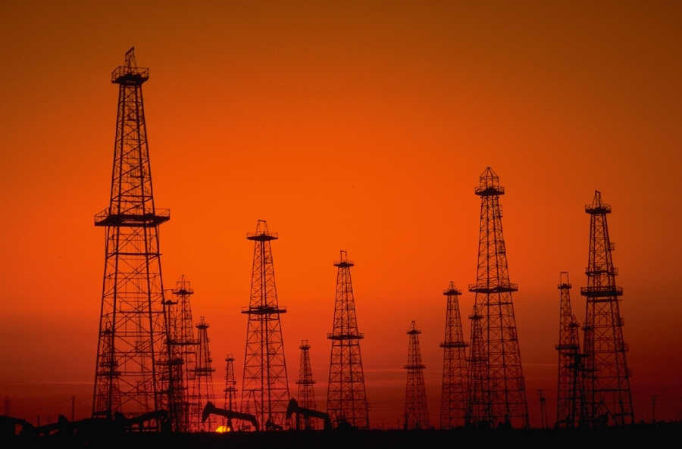

How to deal with governing a country that suddenly experience earning a huge amount of wealth during a limited time. How does a country survive a great success?

**Introduction**

Oil is the main energy resource of the world, and very much depend on it. In 2001 it accounted for 38% of commercial energy (measured in oil equivalents). Coal was next with 25%, and then natural gas with 24%. Since then, the consumption of fossil fuels have growth fast, hand-in-hand with the rapid growth of the Indian and Chinese economies and increased popular wealth used for consumption. Nuclear and hydro-power generated less than 7% each. Countries with large oil reserves and production face especially difficult challenges for planning their future. Oil producing countries may earn un-proportionally much money in a very short time, creating the question, what will it do to us, and then what will we do afterwards ? For the future, with the end of fossil energy in view, this represents on of the toughest and most serious challenges to mankind in all of history. Sadly, very few of out politicians have grasped even the slightest of the aspect of this. Most have no idea whatsoever at all. That is very scary….

**Oil in numbers**

In 2001, the Middle East generated 30% of the world’s oil production, as much as North America and the former Soviet Union combined. Saudi Arabia, the world’s biggest oil producer, supplied 12% of the world total. The region is, at present, a far less important supplier of natural gas. But it produces 14% of the world’s total supply of gas combined. The fundamental driver of the 20th Century's economic prosperity has been an abundant supply of cheap oil. Unlike in the 1970s, this time Middle East’s part of the oil production is set to continue to rise. The share will likely reach 35% by 2003 and 50% by 2009. By then, the Middle East too will be close to its depletion midpoint, and unable to sustain production much longer irrespective of investment or desire. Far more important, in 2001, 36% of the world’s proven reserves of natural gas and 65% of its proven oil reserves were in the Middle East. Saudi Arabia alone had 25% of the world’s oil reserves, followed by Iraq, with 11%, and Kuwait, the United Arab Emirates and former Soviet Union and North America with barely 6% each. Forecasts suggest a 54% increase in total world oil consumption by 2020. If so, good part of the increase is bound to be supplied by Gulf countries (If possible?). The further one looks to the future, the bigger the Gulf’s role will become, unless there is a revolution in energy consumption and production. Sustaining a smooth flow of Gulf oil is therefore a vital long-term interest (although short-sighted), of the US, Europe, Japan and most of the rest of the world. It is also a vital interest of these countries to prevent Saudi Arabia from falling into hostile hands, which means less pro-western.

oilwellfare_1

Figure 1. *World proven oil reserves. End 2001 total: 1050 billion barrels, whereof 685.6 billion barrels in Middle East. Source: BP, MF, Thomson Datastream*.

**Rich and poor at the same time**

The region contains tree oil-producing countries with sizeable populations: Iran with 64 million in 2000, Iraq with 23 million and Saudi Arabia with 21 million. In addition, there are five small oil-producing states – Bahrain, Kuwait, Oman, Qatar, and the United Arab Emirates – with a total population of just over 8 million. Iran had only 39 million people in 1980, just after the revolution. But its population will be 80 million by 2015. Iraq’s population has risen from 13 million in 1980, with 31 million projected for 2015. Thirty-seven per cent of Iranians, 42% of Iraqis and 43% of the Saudi population are below 14 years of age. This rapid population growth has combined with even speedier urbanisation. In 1970, 42% of the Iranians, 49% of Saudis and 56% of Iraqis lived in cities. Today the figures are 61%, 85% and 71% respectively. It is also estimated that disguised and open unemployment affects about 45% of the labour force in Iran and Iraq, and just under 40% in Saudi Arabia. Rich societies of apparently retired persons can afford such idleness. But these countries are not equally rich. Standards of living are also falling as the rent from the oil is shared among more people. Qatar, the United Arab Emirates, Kuwait and Bahrain, will small populations, are comfortably off, so far. At the opposite end of the scale, populous Iran is poor. Its gross national income per head is 111th in the world. At purchasing power parity, its 95th. Saudi Arabia falls in between. In 2000, its income per head was $7230, 61st in the world. But their standard of living is in decline. Saudi Arabia’s real income per head has tumbled by about 60% from its peak at 1980. The nation is becoming under different types of stresses. The Saudi state budget has been in deficit since the Gulf war; its public debt is 107% of its GNP, and government salaries have been frozen for many years. As economic and social stresses have affected these countries, the response has been different varieties of repression. Look at the large countries, Iraq, Iran, and Saudi Arabia. All have different forms of nationalism with none or very poor democratic systems, with very low social sustainability. The prognosis for stability looks grim. The regimes have every interest in diverting the pressure that is arising within to enemies outside. This has taken different directions; in Iran the western hostility after the revolution is now dampened, as an outcome of the war with Iraq. In Iraq, under hard pressure from the single superpower in the world; US, and United Nations, this works as a good excuse for postponing social reforms. Saudi Arabia is an old Islamic and puritanical kingdom. The small states are less of a problem, being so dependent on outside support, and will therefore most likely change faster, if and when needed.

In 2010, Saudi Arabia silently announced that it would close its program for wheat farming in the desert. Several aquifers are pumped dry down to 1,600 m, these are fossil deposits of water, and that desalinization plants working with seawater with oil as energy input, could not keep up with the demand. The program was started 20 years ago in order to make Saudi Arabia self-sufficient on wheat for bread. Now it comes to an end.

oilwellfare_2

*Figure 2. Saudi Arabia’s per capita GDP (in US$ terms) deflated by US Producer Prices, 1980=100, and the real oil price (US$ per barrel), 2002 prices, deflated by US CPI.*

Norway is another type of country, where very much money has been generated from oil, in a country with few people. It is a very stable nation, with old democratic traditions and good infrastructure. How have they coped with the free ride oil money can provide. Much of the money has been saved up, now put aside in a large pension fund. Very little to none of the money is used for long term strategic plans for the country, nothing is funnelled into research nor extra education. The money sits in a huge heaps in banks, investment funds and shares in companies like Coca Cola and Mercedes industry shares abroad. The huge fortune presents the Norwegians with a huge temptation. In Norway there is a lively debate on whether to spend or not to spend, to exploit every as fast as possible or more slowly. The oil has driven up costs for labour, making it very difficult for other industry to survive. Many aspects needs to be considered:

* Privileged groups versus investments for the collective, how to deal with huge temptations, prevent corruption and potential for crime, dealing with long term common wealth versus short term needs and greeds.
* Stratified society versus social equality, hand in hand with oligarchy or democracy
* Imported labour and skills of the population
* Politics, democracy and equality or unequal rights between many groups
* Economic strategies
* Public attitudes and schooling systems
* The disruptions that can be caused by climate change and all the changes in environment that follows from that.

For all of this, you must consider where the proper system boundary is. Internally, use of religion for bolstering power positions. External influences partly through politics and partly through market mechanisms and consumption patterns.

**Sustainability must come to us, before thermodynamics finds us**

The situation for such countries, Iran, Iraq, Norway or Saudi Arabia, is a problematic dilemma. How to promote prosperity built on a large and globally strategic energy resource, which is limited, with rising population levels ? The problem contains parts from all three major sustainability regions; environmental, social as well as economic. The governments in these countries will not have an easy ride. An awareness of the need to control the effects of the country’s oil wealth is not new. The wealth has also been used to build up health and hospital care, infrastructure, and schooling, in different degrees.

So, save or spend, use or invest? Who is favoured and who is not? Who really owns oil in the ground? The guy that stumble upon it? The region? The country? OR does it belong to the global commons? However, with increasing populations, will it be enough? And will it be socially and economically sustainable? What about the attitude towards social and cultural changes in such countries. Price per barrel versus effort? What is the real utilitarian value of oil? When is oil very lucrative and when not? What was the historic development in post-oil economies? Please go to the library and search for relevant literature on

* Production systems and structures
* Producing societies and their problems
* Numbers, sizes, volumes

|  |  |  |  |  |  |
| --- | --- | --- | --- | --- | --- |
| Element | Mining rate  % per yr | Burn-off time yrs | Hubbert-curve decline to 10 % of reserves, yrs | Estimated total world deposits  Ton | World mining rate  Ton/yr |
| Oil | 2.3 | 44 | 99 | 164,000,000,000 | 3,700,000,000 |
| Coal | 1.6 | 78 | 174 | 470,000,000,000 | 6,000,000,000 |
| Gas | 1.6 | 64 | 143 | 164,000,000,000 | 2,600,000,000 |
| Uranium | 1.6  0.048 | 61  7,000 | 142  15,800 | 3,900,000  14,000,000 | 64,000  2,000 |
| Thorium | 1.6  0.016 | 381  11,000 | 142  25,300 | 12,200,000  22,000,000 | 32,000  2,000 |

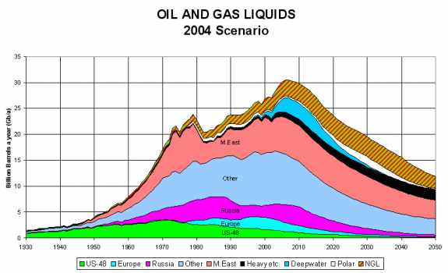



## 4. Trade Route Logistics

A game engine simulation and optimization

**Description of the system and some issues**

****The town of Cottonbog with a population of 30,000 people that mainly sustains themselves on cotton production and trade. Its traders bring the produced cotton to nearby villages and bring back food and other commodities. Cottonbog produces about 25,000 ton of sellable cotton per year. With approximately 1,500 cotton workers to pick, process and regrow the cotton. Cotton working is hard and hazardous, on average the town uses 300 gold staters per person per year to maintain infrastructure, security, and the general health of the people. Currently the town of Cottonbog has 35 active traders that run trading caravans to the markets. Each cart of the standard type can carry approximately 13 ton of cotton, give or take a ton. There is an estimate of 300 bandits in the area around the trade roads at any time. Three nearby towns are each connected to Cottonbog by separate roads:

1. The road to Slagtown is short and safe, and guarded by the local garrison of soldiers, this implies that there is a very low chance of successful bandit raids. Travelling to Slagtown takes about 1 week. However, because this road is so popular, their demand has been lowered, and thus the prices as well. The garrison in the region needs to exact a toll to pay for the guards’ wages. This toll is 250 gold staters one way. Trading with Slagtown yields about 1,000 gold staters per week, not including toll.
2. The road to Coalpeak is long and tiresome, but relatively safe. Travelling to Coalpeak takes about 4 weeks. Trading along this route will yield a trader about 1,000 gold staters a week, and they will not have to pay tolls as the road is not guarded.
3. The road to Goldford is medium in length, but with a rather high chance of raid. Travelling to Goldford takes about 2 weeks. The road is not guarded, so no toll is exacted here either. Trading along this route will generate about 1,500 gold staters per week, if not raided.

Assume that any events (toll, bandit attacks, etc) happens approximately half-way through the road. You can also assume that any successful bandit raid will leave the trader with nothing, no money and no wares.

**Task description**

Develop a model and program it is stella for the basic functioning of the system of production, trade, logistics, gold, population and mass flows. Simulate the development over time.

**Guidance for solving the task**

Some suggestions for how to go about solving the problem.

1. Create a CLD, a flowchart, an RBP, and a table showing items, actions, controls. Figure out for what items you need to make mass balances based on your flow charts.
2. State clearly all the assumptions you will make. Define how you set parameters, and find the values that have not been given.
3. Create a simulation of the town’s population and economic dynamics, trading between the three different towns, and the cotton production. Run the simulations several times for each of the different roads and compare them to each other to see which is more profitable.
4. The bandits themselves are a system of their own. Whenever they raid a road, they steal money and people from the traders, depending on whether the raid was successful or not. Also, with each attempted raid, they increase the preparedness against bandit attacks on the roads. As with any group of people, the bandits have their internal population and economic dynamics that affect their raid dynamics. Introduce the bandits as a new system which interconnects with the other systems.
5. The King in the region wants to aid the locals in growing their economy, therefore he wants to build a new and safer road towards Goldford from Cottonbog. To do this he needs to collect the money first and wants to exact this as a tax from the cotton traders. Building the new road would cost a sum of 100,000 gold staters. This will cut the travel time in half, and it will be just as guarded as the road to Slagtown. Evaluate what kind of tax rate and the amount of time needed to succeed with raising these funds, and if this can be done without harming the economy of Cottonbog.
6. The King wishes to further increase the trade in the region and decrees that Cottonbog needs to increase its trade by 10,000 gold staters per week. Find a solution to this and implement this in your simulation.
7. Report
   1. Write the report, and document how the model is made. Flow charts, table, CLDs, and explain the very well.
   2. Run different scenarios and illustrate them with simulation outputs and explain them properly

1. Based on an idea developed by Sverdrup, Svensson and Haraldsson at LUMES. Written up and revised by Sverdrup and Haraldsson. Israelis and Palestinians have work hard to keep the issue actual. [↑](#footnote-ref-1)
2. Based on an idea and written up by Mats Svensson. Revised by Sverdrup. [↑](#footnote-ref-2)
3. Charles Darwin: Origin of Species (1859) [↑](#footnote-ref-3)
4. Lavenberg, R.J., Grove, J.S. & Seigel, J.A. 1994. Status of fisheries for Galapagos sharks, with checklist of known species. Chondros 5(2): 10-11. [↑](#footnote-ref-4)
5. Jennings, S., Brierley, A.S. & Walker, J.W. 1994. The inshore fish assemblages of the Galapagos Archipelago. Biological Conservation 70: 49-57. [↑](#footnote-ref-5)
6. Camhi, M. & Cook, S. 1994. Sharks in Galapagos in peril. Shark News 2:1-3 [↑](#footnote-ref-6)
7. World Wildlife Fund web site. <http://www.wwf.org/galapagos/timeline.htm>, accessed 2001-10-10. [↑](#footnote-ref-7)
8. Stutz, B. 1995. The sea cucumber war. Audobon Magazine. May-June: 18-20. [↑](#footnote-ref-8)
9. [↑](#footnote-ref-9)
10. Based on an idea by Mats Svensson and written up and revised by Sverdrup. This case is inspired by an article by Martin Wolf, in Financial Times, 4 December 2002. [↑](#footnote-ref-10)